Phase 4 project – BIG DATA ANALYSIS

# PROBLEM STATEMENT:

* Continue building the big data analysis solution by applying advanced Analysis techniques and visualizing the results.
* Apply more complex analysis techniques, such as machine learning Algorithms, time series analysis, or sentiment analysis, depending on the Dataset and objectives.
* Create visualizations to showcase the analysis results. Use tools like Matplotlib, Plotly, or IBM Watson Studio for creating graphs and charts.

# SOLUTION:

Certainly, building a big data analysis solution that incorporates advanced Techniques and visualizations is essential for deriving meaningful insights from Your data. Let’s continue with the process:

# Step 1:

Download a CSV or xlsx file for upload in the DB2 database. Example: open the wwb browser.

Search for the convenient topic to download database.(eg:kaggle,Data.world..)

# Step 2:

Create a data table in IBM Cloud DB2 Database.

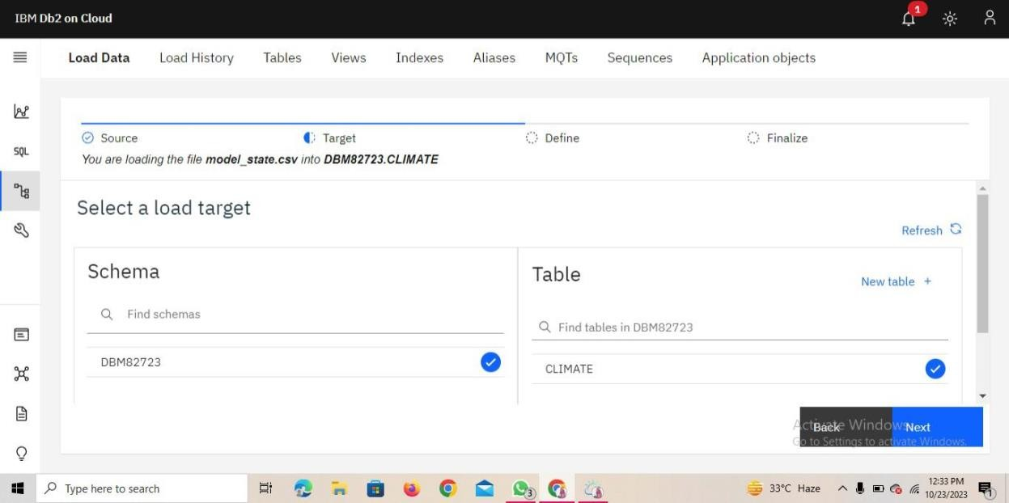

# Step 3:

Upload the downloaded CSV. File in the database.

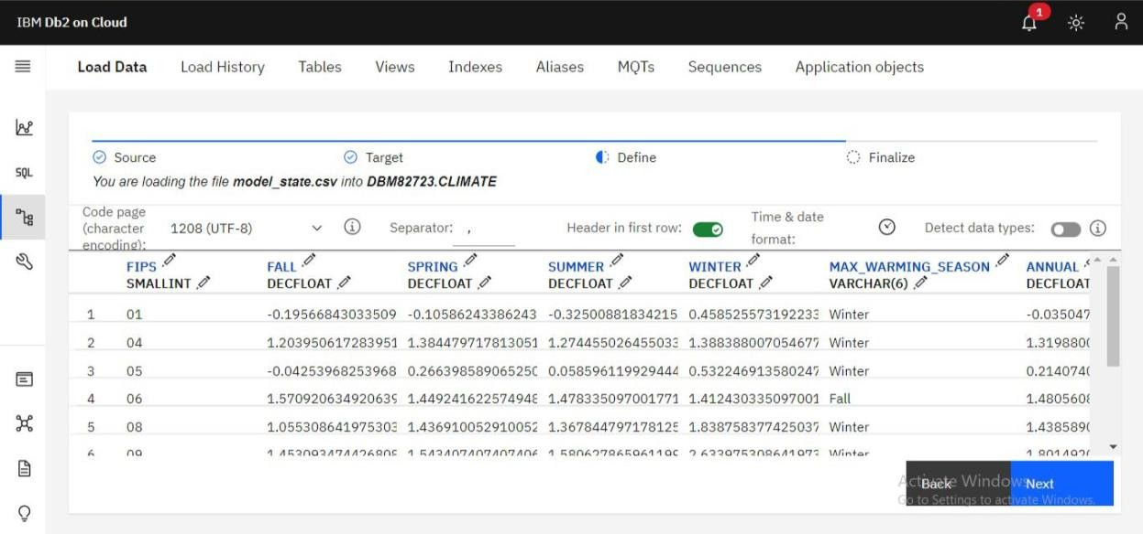

# Step 4:

Finalize the uploading settings.

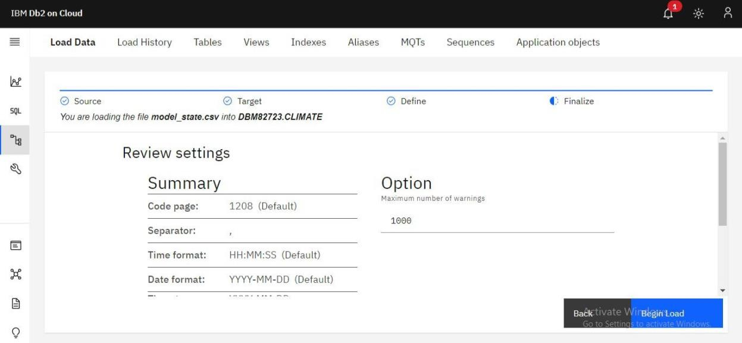

# Step 5:

Run the loaded data to check it is contain error or not.

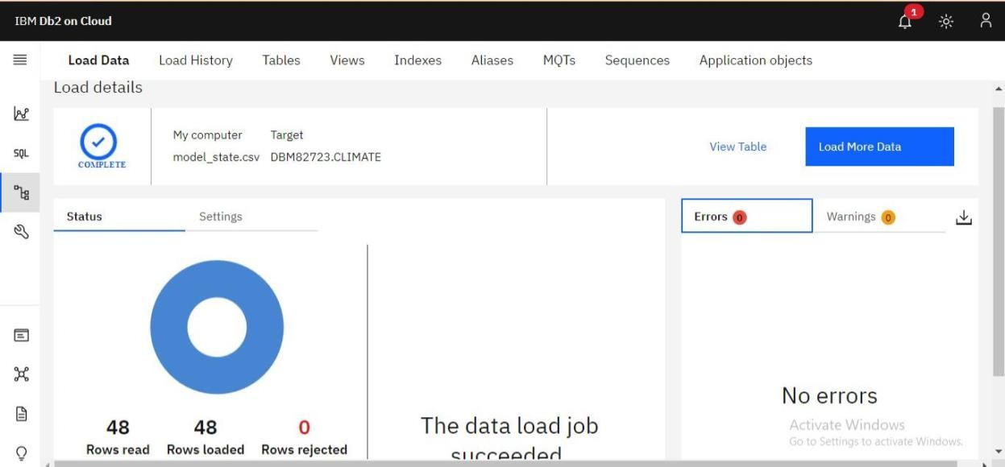

# Step 6:

Create SQL queries to run the database table.

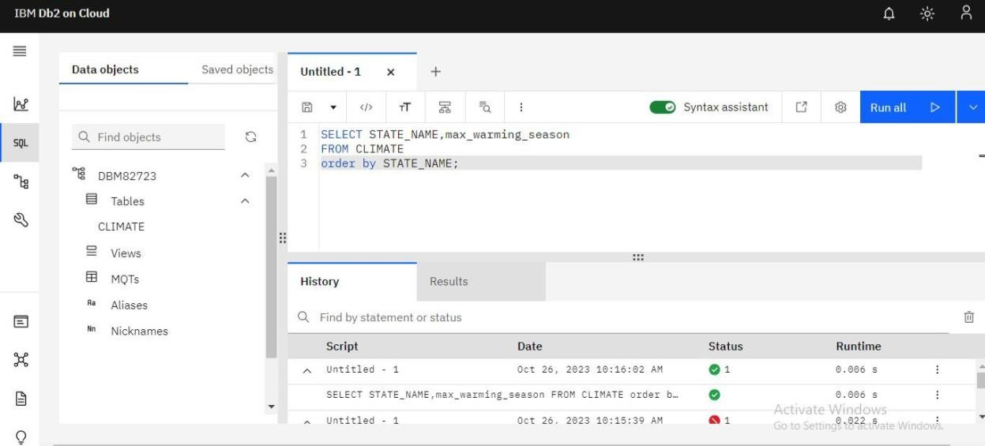

# Step 7:

For development the analysis data we need to use the virtualization techniques in the datasets.

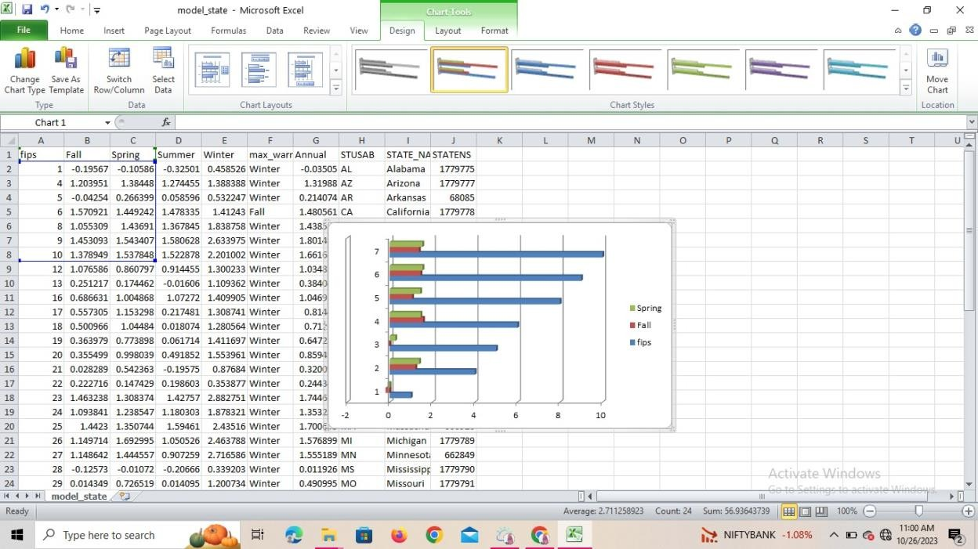

# Step 8: Using python.

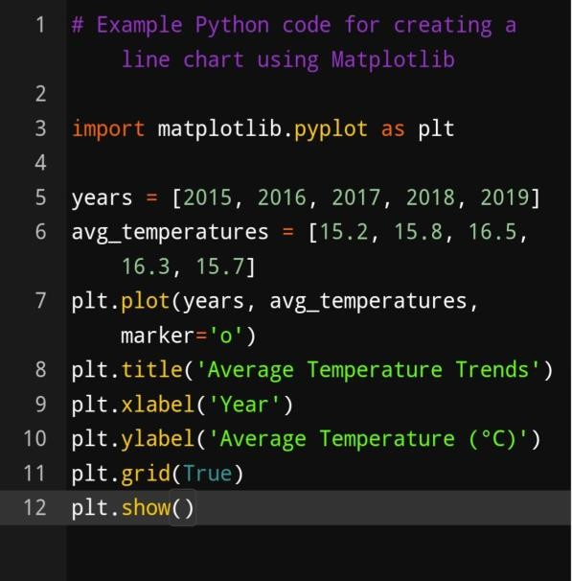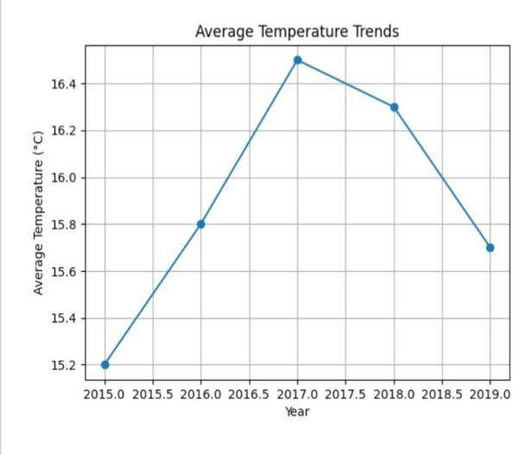

**Step 9:**

# Using Machine Learning techniques. Select Appropriate Analysis Techniques:

Depending on the nature of your dataset and specific objectives, consider various

# Advanced analysis techniques:

**Machine Learning Algorithms:** Use supervised or unsupervised machine learning Algorithms like decision trees, random forests, support vector machines, or Clustering algorithms for predictive modeling or pattern recognition.

**Time Series Analysis:** If your data involves time-based data points, use time Series analysis techniques to identify trends, seasonality, and forecast future Values.

**Sentiment Analysis**: Apply natural language processing techniques to extract Sentiment from text data, useful for social media or customer reviews analysis. **Example:**

# Example Python code for sentiment analysis using NLTK import nltk

from nltk.sentiment import SentimentIntensityAnalyzer nltk.download(‘vader_lexicon’)

sia = SentimentIntensityAnalyzer()

text = “The weather is wonderful and the scenery is breathtaking.” sentiment_score = sia.polarity_scores(text)

print(sentiment_score)

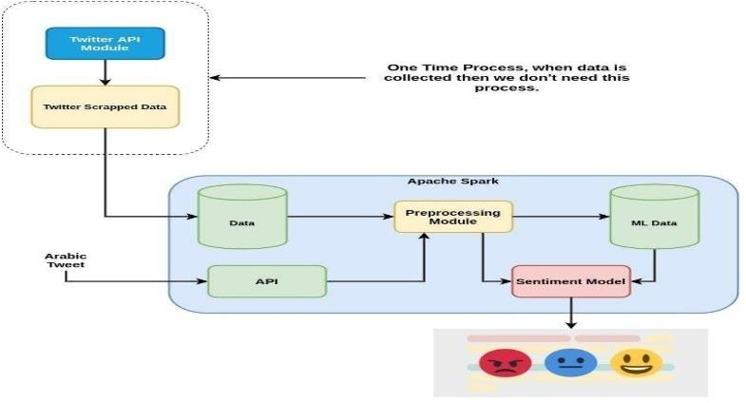

# Conclusion:

Thus the ,Continue building the big data analysis solution by applying advanced analysis techniques And visualizing the results has been completed.